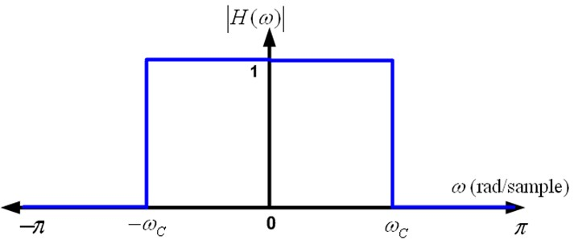

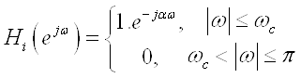

**Fig: Magnitude response of ideal low pass filter**

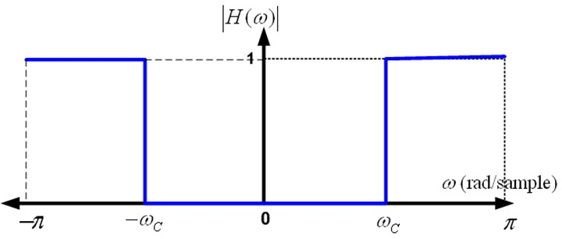

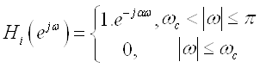

**Fig: Magnitude response of ideal high pass filter**

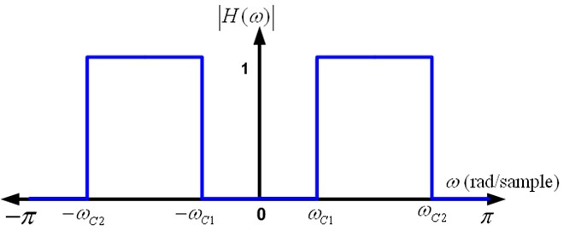

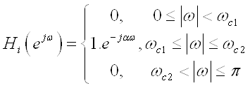

**Fig: Magnitude response of ideal band pass filter**

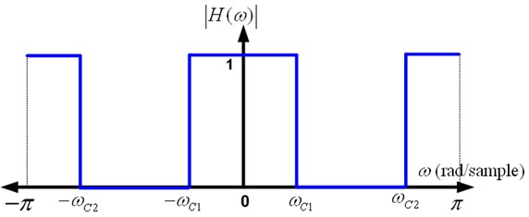

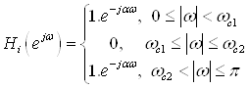

**Fig: Magnitude response of ideal band stop filter**